Chapter 18, Problem 8.

Obtain the Fourier transforms of the signals in Fig. 18.33.

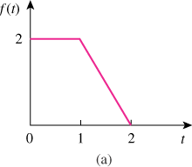

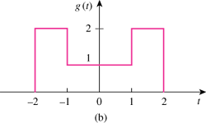

Figure 18.33
For Prob. 18.8.

